VFW DISTRICT 11 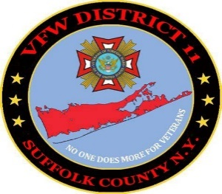FUNDRAISER

Comrades,

We are glad that summer has arrived, a beautiful time of year in our State and hope you enjoy the season as much as we do in Suffolk County, Long Island. With that said our Commander William Hughes is in training for his annual kayak crossing of Long Island Sound from Bridgeport CN to Port Jefferson NY, supporting PAC22 and bringing awareness to the alarming rate of Veteran’s suicide. We in District 11 are using this challenging kayak sea crossing (22 nautical miles) to help us help others in our District and to keep our budget in the black while also supporting PAC22. The Commander will team up with a VFW member from Post 5350 as this is a two-person kayak. We will also have a membership and Poppy table setup at the finish and reception area, and all are welcome to attend the finish at Port Jefferson Harbor at approximately 17:00 hours. This crossing will take at least eight hours. You will be able to recognize our kayak as we will be flying our VFW flag. What we are asking for is a $22. Donation to support this effort and hope that you will share this with the Posts in your District. The date of the event is Friday, August 30th, 2024, checks call be mailed to our VFW District 11 PO Box 1492, Ronkonkoma NY 11779 or use this convenient QR code, thank you in advance for your support and in this important challenge.

William Hughes, Commander VFW District 11